**Practical-8**

**AIM:** To implement Dijikstra Algorithm in C language

**SOFTWARE REQUIRED:** Vs Code

**PSEUDO CODE:**

function Dijkstra(graph, source):

Initialize dist array with infinity values

Set dist[source] = 0

Initialize visited array with false values

Repeat for each vertex v:

u = Unvisited vertex with the smallest known distance from source

Mark u as visited

For each neighbor v of u:

if dist[u] + weight(u, v) < dist[v]:

Update dist[v] = dist[u] + weight(u, v)

Update predecessor[v] = u

Return dist array

**CODE:**

#include <stdio.h>

#include <stdlib.h>

#include <limits.h>

#define V 10

int minDistance(int dist[], int visited[], int n) {

    int min = INT_MAX, min_index;

    for (int v = 0; v < n; v++) {

        if (!visited[v] && dist[v] <= min) {

            min = dist[v];

            min_index = v;

        }

    }

    return min_index;

}

void printSolution(int dist[], int n) {

    printf("Vertex \t Distance from Source\n");

    for (int i = 0; i < n; i++)

        printf("%d \t %d\n", i, dist[i]);

}

void dijkstra(int graph[V][V], int source, int n) {

    int dist[V];

    int visited[V];

    for (int i = 0; i < n; i++) {

        dist[i] = INT_MAX;

        visited[i] = 0;

    }

    dist[source] = 0;

    for (int count = 0; count < n - 1; count++) {

        int u = minDistance(dist, visited, n);

        visited[u] = 1;

        for (int v = 0; v < n; v++) {

            if (!visited[v] && graph[u][v] && dist[u] != INT_MAX &&

                dist[u] + graph[u][v] < dist[v]) {

                dist[v] = dist[u] + graph[u][v];

            }

        }

    }

    printSolution(dist, n);

}

int main() {

    int n;

    printf("Name:Ananta Walli");

    printf("\nEnrollment No:A2305221322");

    printf("\nEnter the number of vertices: ");

    scanf("%d", &n);

    int graph[V][V];

    printf("Please enter the adjacency matrix:\n");

    for (int i = 0; i < n; i++) {

        for (int j = 0; j < n; j++) {

            scanf("%d", &graph[i][j]);

        }

    }

    int source;

    printf("Please enter the source vertex: ");

    scanf("%d", &source);

    dijkstra(graph, source, n);

    return 0;

}

**OUTPUT:**

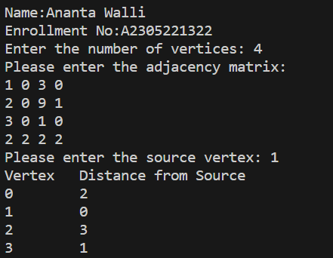

**RESULT:** The above code implements the Dijikstra Algorithm in C programming.